PIZZA SALES REPORT

Show Table

SELECT * FROM pizza_sales

Output:

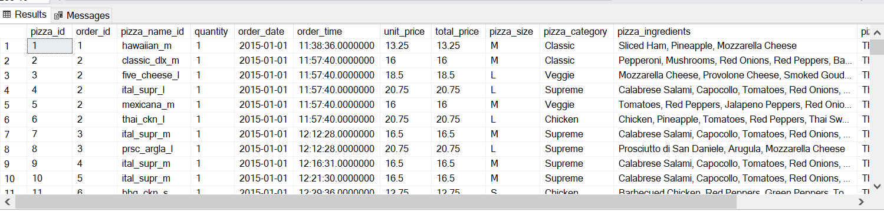

***KPI’s:***

1 . Total Revenue:

SELECT CAST(SUM(total_price) AS decimal(10,2)) AS Total_Revenue from pizza_sales

Output:

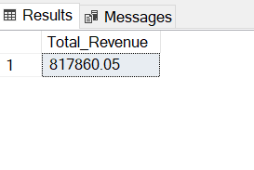

2 . Average Order Value:

SELECT SUM(total_price) / COUNT(DISTINCT order_id) AS Avg_Order_Value from pizza_sales

Output:

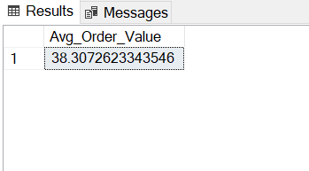

3 . Total Pizza Sold:

SELECT SUM(quantity) AS Total_Pizza_Sold FROM pizza_sales

Output:

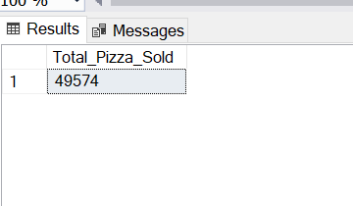

4 . Total Orders:

SELECT COUNT(DISTINCT order_id) AS Total_Order from pizza_sales

Output:

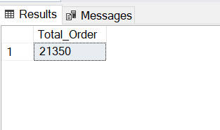

5 . Average Pizza’s Per Order:

SELECT CAST(CAST(SUM( quantity ) AS decimal(10,2)) / CAST(COUNT(DISTINCT order_id) AS decimal(10,2)) AS decimal(10,2)) AS Avg_Pizzas_per_Order FROM pizza_sales

Output:

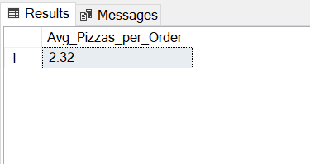

6 . Daily Trend For Total Order:

SELECT DATENAME(DW, order_date) as order_day, COUNT(DISTINCT order_id) AS Total_Orders

from pizza_sales

GROUP BY DATENAME(DW, order_date)

Output:

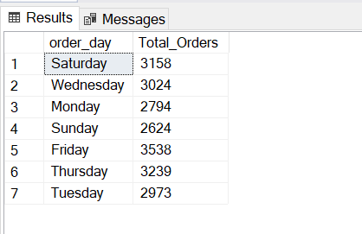

7 . Montly Trend For Order:

SELECT DATENAME(MONTH, order_date) as Order_Month, COUNT(DISTINCT order_id) AS Total_Orders

from pizza_sales

GROUP BY DATENAME(MONTH, order_date)

ORDER BY Total_Orders DESC

Output:

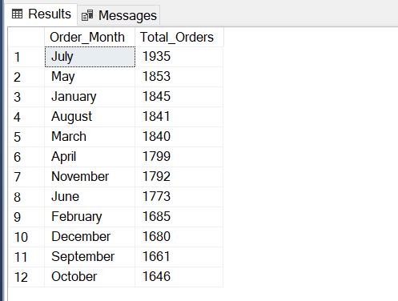

8 . Percentage Of Total Sales By Pizza Category:

SELECT pizza_category, SUM(total_price) AS Total_Sales, SUM(total_price) * 100 /

(SELECT SUM(total_price) From pizza_sales

WHERE MONTH(order_date) = 1) as PCT

FROM pizza_sales

WHERE MONTH(order_date) = 1

GROUP BY pizza_category

Output:

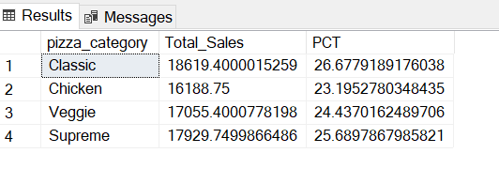

8 . Percentage Of Total Sales By Pizza Size:

SELECT pizza_size, SUM(total_price) AS Total_Sales, SUM(total_price) * 100 /

(SELECT SUM(total_price) From pizza_sales ) AS PCT

FROM pizza_sales

GROUP BY pizza_size

ORDER BY PCT DESC

Output:

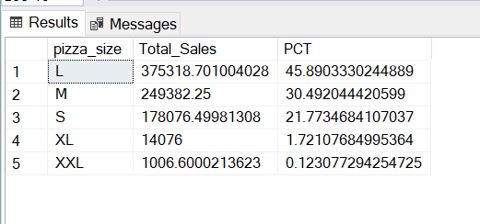

9 . Bottom 5 Pizza By Total Revenue:

SELECT TOP 5 pizza_name, SUM(total_price) AS Total_Revenue FROM pizza_sales

GROUP BY pizza_name

Order By Total_Revenue ASC

Output:

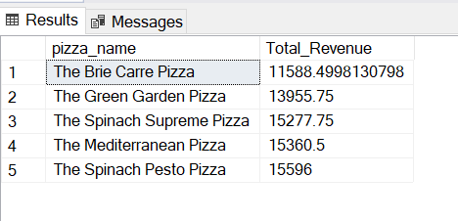

10 . Top 5 Pizza by Total Revenue:

SELECT TOP 5 pizza_name, SUM(total_price) AS Total_Revenue FROM pizza_sales

GROUP BY pizza_name

Order By Total_Revenue DESC

Output:

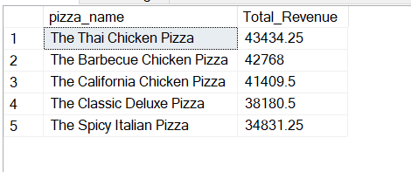

11 . Bottom 5 Pizza By Quantity:

SELECT TOP 5 pizza_name, SUM(quantity) AS Total_Quantity FROM pizza_sales

GROUP BY pizza_name

Order By Total_Quantity ASC

Outout:

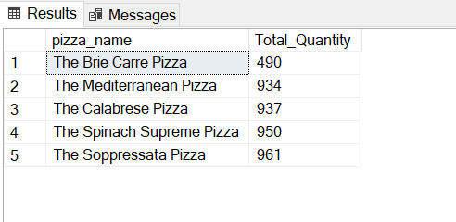

12 . Top 5 Pizza By Quantity:

SELECT TOP 5 pizza_name, SUM(quantity) AS Total_Quantity FROM pizza_sales

GROUP BY pizza_name

Order By Total_Quantity DESC

Output:

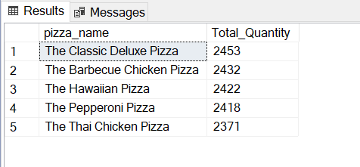

13 . Bottom 5 Pizza By Order:

SELECT TOP 5 pizza_name, Count(DISTINCT order_id) AS Total_Order FROM pizza_sales

GROUP BY pizza_name

Order By Total_Order DESC

Output:

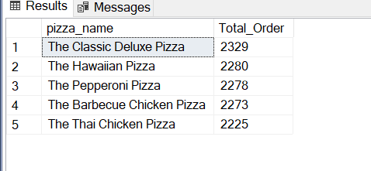

14 . Top 5 Pizza By Order:

SELECT TOP 5 pizza_name, Count(DISTINCT order_id) AS Total_Order FROM pizza_sales

GROUP BY pizza_name

Order By Total_Order ASC

Output:

